**SMART POWER SAVING USING RASPBERRY PI**

A TERM PAPER REPORT SUBMITTED IN PARTIAL FULFILMENT OF THE DEGREE OF

BACHELOR OF TECHNOLOGY

IN

INFORMATION TECHNOLOGY

BY

G HARSHITHA (19K61A1215)

UNDER THE ESTEEMED GUIDANCE OF

G NAGESWARA RAO

ASSOCIATE PROFEESOR

DEPARTMENT OF INFORMATION TECHNOLOGY



**SASI INSTITUTE OF TECHNOLOGY & ENGINEERING**

ACCREDITED BY NAAC WITH ‘A’ GRADE RECOGNIZED BY UGC 2(F) & 12(B) (APPROVED BY AICTE, NEW DELHI, PERMANENTLY AFFLIATED TO JNTUK, KAKINADA AND SBTET-HYDERABAD, RANKED AS ‘A’ GRADE BY GOVT. OF. AP.)

KADAKATLA, TADEPALLIGUDEM – 534101

**ACADEMIC YEAR 2020-2021**

**CERTIFICATE**

This is to certify that the **TERM PAPER** work titled **“SMART POWER SAVING USING RASPBERRY PI”** is submitted by **G Harshitha (19K61A1215)** in partial fulfilment for the award of Degree of **BACHELOR OF TECHNOLOGY in INFORMATION TECHNOLOGY** to the **SASI INSTITUTE OF TECHNOLOGY & ENGINEERING** during the academic year 2021-2022 is a record of Bonafide work carried out by them under our guidance and supervision.

**Project Guide: Head of the Department:**

Mr. Nageswara Rao.M.Tech Dr. K Subhash Bhagavan.M.Tech, Ph.D. Associate Professor Associate Professor, HOD

Department of IT Department of IT

**DECLARATION BY THE CANDIDATES**

We **G Harshitha (19K61A1215)** hereby declare the project report entitled **“SMART POWER SAVING USING RASPBERRY PI”** under esteemed supervision of Mr. **G. Nageswara Rao,** is submitted in partial fulfilment of the requirements for the award of the degree of **Bachelor of Technology** in **Information Technology.** This is a record of work carried out by us and the results embodied in this Term paper have not been reproduced or copied from any source. The results embodied in this Term paper report have not been submitted to any other University or Institute for the award of any other degree or diploma**.**

**G Harshitha (19K61A1215)**

**ACKNOWLEDGEMENT**

We pay obeisance to the dynamic Chairman of Sasi Educational Society, Sri **Burugupalli Venu Gopala Krishna**, for his inspiring presence, which has always been the principle driving force behind all over endeavours.

First of all, we would like to thank **Mr. Meka Narendra Krishna**, Vice- Chairman, Sasi Institute of Technology Engineering, for his everlasting support.

We would like to thank **Dr. J Anand Chandulal**, Principal, Sasi Institute of Technology Engineering, for his support.

We would like to thank **Dr. K.Bhanu Prasad**, Director, Sasi Institute of Technology Engineering, for his support.

We would like to thank **Dr. K Subhash Bhagvan**, Associate Professor and Head of the Department, Information Technology, for providing us with invaluable feedback on our work, which allowed us to constantly improve.

We are grateful to our Term paper coordinator **Dr. A.V.N. Chandra Sekhar**, Professor and thanks to all teaching and non-teaching staff members those who contributed for the successful completion of our Term paper.

We would like to take the opportunity to express my heartfelt gratitude to one Term paper **Mr. G.Nageswara Rao**, Assistant Professor, Sasi Institute of Technology and Engineering for his constant encouragement, monitoring and guidance throughout the Term paper. He motivated us whenever we encountered an obstacle.

**G Harshitha (19K61A1215)**

**VISION AND MISSION OF INSTITUTE**

**VISION**

Confect as a premier institute for professional education by creating technocrats who can address the society’s needs through inventions and innovations.

**MISSION**

1. Partake in the national growth of technological, industrial, industrial area with societal responsibilities.

2. Provide an environment that promotes productive research.

3. Meet stakeholder’s expectations through continued and sustained quality improvements.

**VISION AND MISSION OF DEPARTMENT**

**VISION**

To become recognized centre of Excellence for quality IT Education and create professionals with ability to solve social needs.

**MISSION**

1. To provide quality teaching learning environment that build necessary skills for employ-ability and career development.

2. To conduct training’s/events for overall development of stakeholders with collaborations.

3. To impart value education to students to serve society with high integrity and good character.

4. Provide state of the art facilities to enable innovation, student centric learning.

**SMART POWER SAVING USING RASPBERRY PI**

Mr.G. Nageswara Rao (ASSOCIATE PROFESSOR), Gandham Harshitha (19K61A1215)1, Vakalapudi Bhanu Harshitha (19K61A1250)2, Atmakuri Pavan Sai (19K61A1206)3, Yalamati Naveen (19K61A1254)4

*STUDENTS OF DEPARTMENT OF INFORMATION TECHNOLOGY, TADEPALLIGUDEM, INDIA, SASI INSTITUTE OF TECHNOLOGY & ENGINEERING*

**Abstract: - In our daily life situations the electricity can be saved with reduction of wastage and unwanted illuminance this system can be useful for taking a step toward a modern lifestyle, whenever there is an occupancy in the room the lights using raspberry pi led turns on and turns off in case of no occupancy respectively with python programming, using this system in day to day life the electrical wastage is more and to reduce the more consumption this system is used for automation, we can also measure light intensity of surroundings using raspberry pi using different light scenarios.**

**Keywords: Automation, Raspberry Pi, light intensity, modern.**

**I. INTRODUCTION**

Lighting is an essential element of construction. Lights enhance the aesthetics of indoor regions and reduce power costs. Achieving the advantages requires combining natural and artificial mild reasserts early within the development format process. Lighting controls facilitate addressing power conservation, provide customers more desire, and make lighting fixtures devices more flexible. The most, common region lighting fixtures method nowadays is the on/off transfer Artificial lighting fixtures constitute a top factor of power consumption, accounting for an important factor of all power consumed worldwide. Raspberry Pi is more straightforward to apply than the usage of microcontrollers and raspberry must be coded with the usage of python.

**II. NEED OF SYSTEM**

Electricity is becoming extra luxurious while its consumption is getting massive. To reduce electric-powered consumption in enterprise corporation construction, we need effective lights device. Artificial lights make contributions severely to electric electricity consumption worldwide. People always forget to reveal off the moderate in their house once they go out so the room is lit no matter the reality that there may be no need for it. People always neglect to replace the lighting fixtures whilst now no longer vital these reasons a massive electric powered wastage, raspberry is used on this paper to transfer on/off lighting fixtures the usage of respective sensors. So, we need a realistic lights device, that makes use of the day lights of the room and shuts off while no individual is in.

**III. LITERATURE SURVEY**

**3.1 Automatic Light Control System:**

This was completed in 2009 by Mohd Amir Hamzah. His project is predicated on by comparing the encircling light-weight and also the intensity within the space to work out whether or not to modify the light or not. The paper encountered some problems such as the system operating for a limited time because the component heats up pretty fast when the system is turned on but overall[1].

**3.2 Intelligent Lighting System for Commercial Building:**

This was done by Sukor Bin Muhammad in 2009. He only focused on employing an occupancy sensor and a photosensor to turn on and off the lights in his intelligent lighting system. He also proposes that an intelligent lighting system be completed with a dimming circuit[4].

**3.3 Lighting Control System for the Home:**

In 2009, Goh Lin Chian completed this task. Based on the project title Itself, this project used an automation concept to control the lights in the house. The system used a motion detector to detect passers-by in the area to turn on and off the lights automatically. He also designed a graphic user interface (GUI) to control the lights from personal computers and also used a local area network (LAN) to interconnect other computers in any part of the house[8].

**IV. DESCRIPTION OF HARDWARE IMPLEMENTATION**

**4.1 PIR SENSOR:**

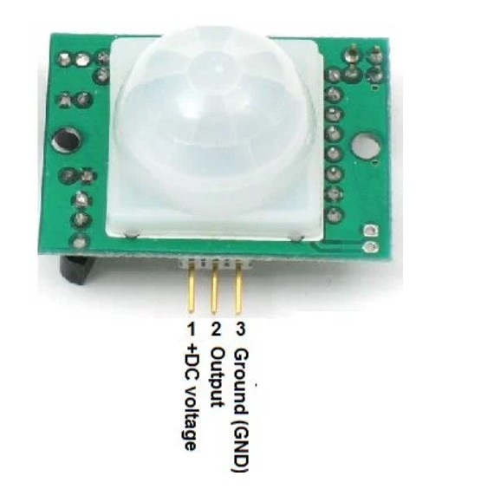PIR means passive infrared which detects human movement. A Fresnel lens, an infrared detector, and a motion sensor make up this motion sensor, supporting detection circuitry. Any infrared radiation present on the sensor is focused spherically in the direction of the infrared detector by the lens on the sensor.

**Fig 4.1.1:** PIR Sensor

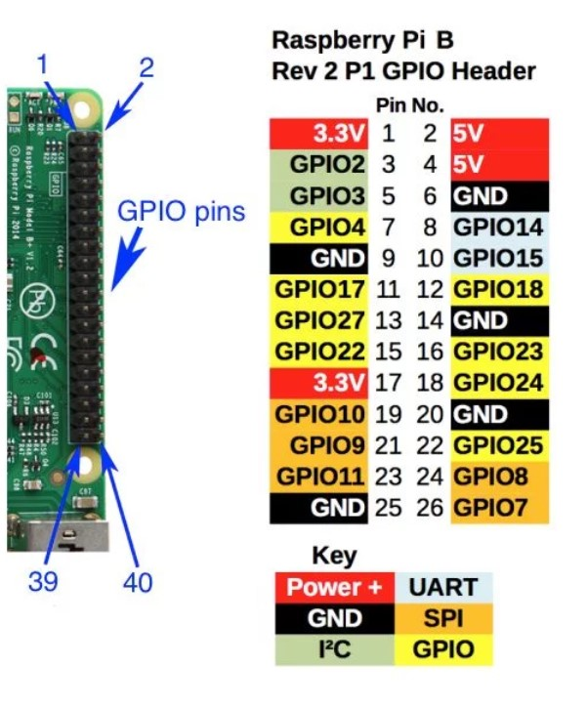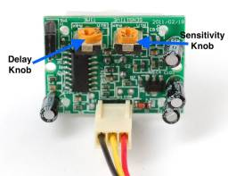Our bodies produce infrared heated temperatures, which can be detected with the help of a motion sensor. As soon as the sensor **Fig 4.1.2:** PIR knobs

senses the presence of a person, it sends out a 5 volt signal for one minute. It has a detection range of around 6 to 7 metres and is quite sensitive.

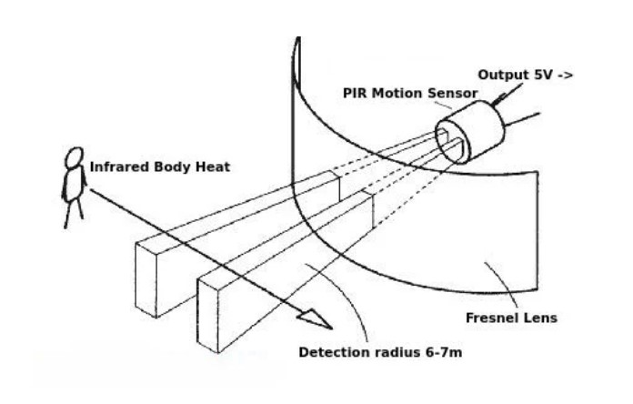When the Passive Infrared Radiation Motion Sensor detects a person, it sends a 5 volt signal

**Fig 4.1.3:** PIR Human Detection

to the Raspberry Pi's GPIO, and we use Python to define what the Raspberry Pi should do when it detects an intruder.

**4.2 RASPBERRY PI PICO:**

The Raspberry Pi is a low-cost notebook that connects to a laptop display or television and uses a standard keyboard and mouse. It's a successful small tool that allows people of all ages to learn about computing and programming languages like Scratch and Python. It can perform all of the tasks that a

computer laptop can, including accessing the internet and watching high-definition video for spreadsheets, word processing, and casino **Fig 4.2.1:** Raspberry Pi Pins

games. To govern electronics applications, it is used in open-source with the appropriate coding. Each pin on the Raspberry Pi is labelled according to its order (1,2,3,...) as seen in the diagram.

**4.3 LED:**

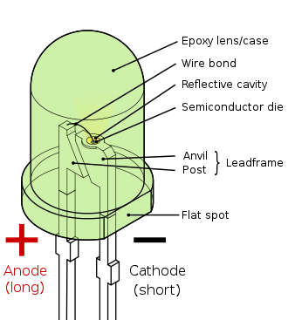When current is passed via a light-emitting diode, it creates light. The semiconductor's electrons recombine with electron holes to create photons, which have energy released. The colour of the light depends on the amount of energy required for electrons to cross the semiconductor's band gap. White light is produced by a combination of semiconductors or a light-emitting phosphor coating on a semiconductor device.

**Fig 4.3.1:** LED

**V. BLOCK DIAGRAM**

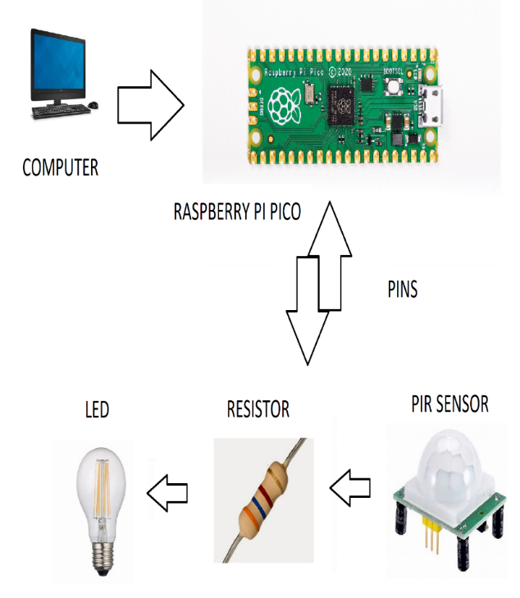

**Fig 5.1:** Automation of light by a motion sensor and Raspberry

The raspberry pi is connected to the computer to implement the code and the raspberry pi is connected to the PIR sensor to identify the radiations which results in the automation of lights or fans.

**VI. INTERFACE WITH PIR SENSOR**

When we place our palm over the sensor, we can see that this system prints Intruder detected. We can fix the delay at which the sensor emits a HIGH signal without sacrificing the accuracy of certain PIR motion sensors by turning the two screws on the sensor counter clockwise with a screwdriver. The PIR sensor, resistor, and led are all connected to the Raspberry Pi, and the code is developed to turn the led light on or off as needed

The file “raspberrypi.py” is implemented in which the infinite loop takes the input from the respective pins until true since the sensor sends the data continuously checks if the output of the sensor is low, and prints no radiations of humans since it is placed in an infinite loop if there is no detection continuous no detection will be displayed, on the other hand, if the output of motion sensor is high then LED is turned on respectively as in infinite loop the code will be continuous.

**VII. MEASURE LIGHT INTENSITY**

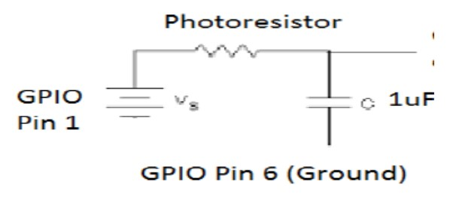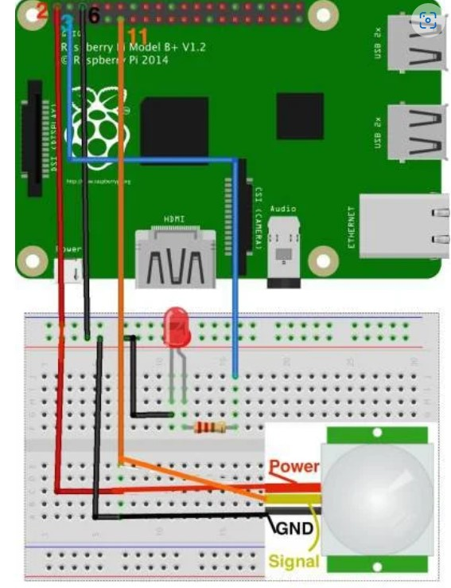Additionally, to measure light intensity LDR is used and the respective illuminance is shown with the help of raspberry and resistor. Respective python code is given for measuring light intensity which gives output in lux (units of luminance). The light measurements are not strictly measurements of light at all; they are measurements of the time taken for a capacitor to fill and discharge. Longer times suggest a larger resistance (and a darker room), whereas shorter times indicate the opposite. The capacitor is connected to a light-dependent resistor.

**Fig 7.1:** A simple setup of automation

These values should be transformed to make interpretation more intuitive. I’ve played with a few transformations, but my current thinking is to use the normalized inverse of the natural log:

y= *f* ()

Where f is the normalization function:

**Fig 7.2:** Photoresistor circuit for LUX

This transformation has three benefits:

•It reverses the values, so that high numbers relate to more light, which is more intuitive.

•It reduces the distinction between low and high values, making patterns easier to discern, and reducing the impact of outliers.

•It sets the light values on a scale of 0 to 1, with 0 being most dark, and 1 being most light (across the whole year).

The photoresistor's resistance must be measured. The Raspberry Pi serves as the battery, with the photoresistor receiving 3.3 V from GPIO pin 1. Make pin 12 of the GPIO a bidirectional pin (input and output pin). The capacitor will take some time to charge to a voltage that reads as high. The negative side of the capacitor is linked to GPIO pin 6, which is grounded (short end). Calculate the resistance of the photocell by measuring how long it takes for the input pin to get high.

A capacitor is a type of electrical component that can temporarily store electrical energy. It is characterised by capacitance and measured in Farads. The capacitor is made up of two conductors that can keep an electric charge until it is fully charged, at which point it begins to discharge. AC is generated using this type of alternative behaviour. When the switch is pressed, current begins to flow and the capacitor begins to charge. When the voltage at the capacitor's end approaches the voltage of the battery, the capacitor stops charging. There is no current flow in the upper portion of the circuit because there is no potential difference.

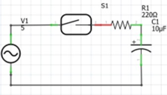

**Fig 7.2:** Simple Circuit for light intensity measurement

**VIII. RESULTS**

The above-proposed system automatically controls the lights using raspberry pi to automatically control the lights, and also measure the light intensity. The light intensity varies in presence of lights and in absence of light the illuminance differs in terms of lux (units of luminance).

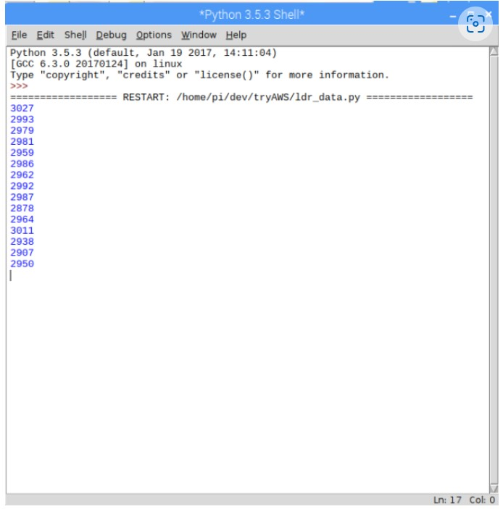**WITH LIGHT:**

**Fig 8.1:** LUX with light

**WITHOUT LIGHT:**

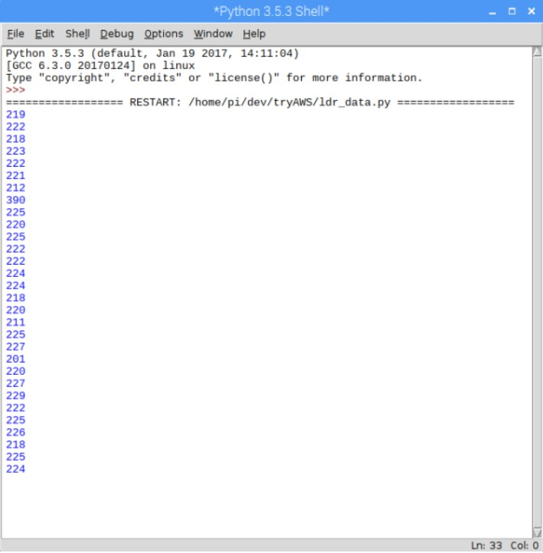

**Fig 8.2:** LUX without light

The lux(luminance) is more than 2890 LUX when there is no light. Using a Raspberry Pico and appropriate resistors, the LDR or photocell detects the intensity. As demonstrated in the diagrams above, the lux ranges from 200 to 300 LUX.

**IX. CONCLUSIONS**

In this paper, a smart power-saving system using Raspberry Pi is implemented. The implementation involves sensors that sense when light is to be turned on or off by detection of radiation of respective sensor. With this system, the manual assistance is reduced by switching off the lights and appliances when not needed for certain conditions, as Raspberry Pi is flexible and easy to use future scope is admirable, because wastage is on the rise in India, and this method is simple to set up and operate. The future scope of this system is huge since the use of microcontrollers is tough which includes various difficult wire connections but our system has a great platform to deploy controlling appliances automatically.

**X. REFERENCES**

[1] The Sensorial IoT platform, 13th IEEE Annual Consumer Communications & Networking Conference (CCNC), 2016, pp. 286–287 Q. Mahmoud and D. Qendri.

[2] Smoothie Charts: Ten Minute Tutorial, J. Walnes, Smoothiecharts.org, 2016. [Online]. Available: http://smoothiecharts.org/tutorial.html [Retrieved: 8 June 2016 Microsoft Azure: Cloud Computing Platform & Services, 2016, available at Azure.microsoft.com Available online at https://azure.microsoft.com [Retrieved: 11 July 2016] .

[3] Azure.microsoft.com, "Microsoft Azure: Cloud Computing Platform & Services", 2016. Available online at https://azure.microsoft.com [Retrieved: 11 July 2016] .

[4] "Globally Accessible Machine Automation Using Raspberry Pi based on Internet of Things" by V. Sandeep, K. Lalith Gopal, S.Naveen, A. Amudhan, and L. S. Kumar. The 2015 International Conference on Advances in Computing, Communications, and Informatics (ICACCI), pages 1144–1147.

[5] IEEE Proceedings of the 2015 Global Conference on Communication Technologies, "IoT based Monitoring and Control System for Home Automation," pp.169–173, 2015.

[6] Wireless Sensor Network System Design Using Raspberry Pi and Arduino for Environmental Monitoring Applications, S. Ferdoush and X. Li, Procedia Computer Science, vol. 34, pp. 103-110, 2014.

[7] "WSN for traffic monitoring using Raspberry Pi board," Computer Science and Information Systems (FedCSIS), 2014 Federated Conference on, vol., no., pp.1023,1026, 7-10 September 2014. Kochlan, Hodon, Cechovic, L., Kapitulik, J., and Jurecka, M.

[8] Chung-Chou Shen, Yu-Wei Su, and Jin-Shyan Lee A comparison of Bluetooth, UWB, ZigBee, and Wi-Fi wireless protocols, 2014.

[9] Lovely Goyal, AnantVaibhav, and Sarthak Jain "Raspberry Pi based "interactive home automation system using e-mail," 2014 International Conference on Reliability, Optimization and Information Technology - ICROIT 2014, pp.277-280.

[10] International Conference on Reliability Optimization and Information Technology (ICROIT), 2014, pp. 277–280. "Raspberry Pi based interactive home automation system over E-mail." A. Vaibhav, S. Jain, and L. Goyal.

[11] Circuit, Power and Computing Technologies (ICCPCT), 2014 International Conference on, vol., no., pp. 1468, 1473, 20-21 March 2014. Wireless sensor network communication terminal based on embedded Linux and Xbee. Sudhir G. Nikhade and A.A. [12] Kelly, Sean Dieter Tebje, Subhas Chandra Mukhopadhyay, and Nagender Kumar Suryadevara. "In the direction of implementing IoT for home environmental condition monitoring." IEEE 13.10 (2013): 3846–3853 in the Sensors Journal.

[13] Securesensor node with Raspberry Pi, S. Banerjee, D. Sethia, T. Mittal, U. Arora, and A. Chauhan, IMPACT-2013, pp. 26–30, 2013.

[14] "Development of Fire alarm system utilising Raspberry Pi and Arduino Uno," Electrical, Electronics and System Engineering (ICEESE), 2013 International Conference on, vol., no., pp. 43, 48, 4-5 Dec. 2013, by Bin Bahrudin, M.S., Abu Kassim, R., and Buniyamin, N Raspberry Pi as a Wireless Sensor node: Performances and Constraints, 2014 37th International Convention on Information, V. Vujovic and M. Maksimovic.

[15] "Daily Life Activity Tracking Application for Smart Homes Using Android Smartphone," 2012 International Conference on Advanced Communication Technology (ICACT), pp. 19–22.

[16] Xiaohui Cheng and Fanfan Shen's design for a wireless sensor network communication terminal running embedded Linux was published in Software Engineering and Service Science (ICSESS), the 2011 IEEE 2nd International Conference on, vol., no., pp. 598–601, from July 15–17, 2011.

[17] Giacomo Morabito, Antonio Iera, and Luigi Atzori published "The internet of things: A survey" in Computer networks, volume 54, issue 4, 2010, pages 2787–2805.

[18] Applications of web technology in wireless sensor networks, The 3rd IEEE International Conference on Computer Science and Information Technology (ICCSIT), 2010; X. Wei, J. Liu, and G. Zhang.

[19]Wireless Networks, Springer/ACM, Volume 16, Issue 4, May 2010, pp. 1091–1108: "Integration of wireless sensor networks with environmental monitoring cyber infrastructure". M.F. Acevedo, S. Fu, X. Li, J. Yang, C. Zhang, and Y. Huang.

[20]IEEE Transactions on Consumer Electronics, vol. 52, no. 3, August 2006, pp. 742–749; J. S. Lee, "Performance evaluation of IEEE 802.15.4 for low-rate wireless personal area networks."

[21] "MoteLab: A Wireless Sensor Network Testbed," Fourth International Symposium on Information Processing in Sensor Networks, Boise, ID, USA, April 2005. P. Swieskowski, G. Werner-Allen, and M. Welsh

[22] The Principle of Some Temperature Transducers in Common Use and Development, J. Ma, X.G. Li, and W. Ning, China Instrumentation, No. 6, pp. 1-2, 2004.

[23] A survey of sensor networks was published in the August 2002 issue of the IEEE Communications Magazine by F. Akyildiz, W. Su, Y. Sankarasubramaniam, and E. Cayirci.

